atitit 代理提成系统 uksrQbf1507 标准化规范 草案解决方案 .docx

高级代理 4

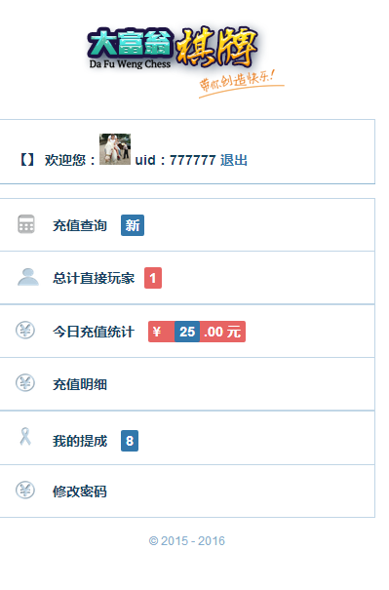

## V2 规划 com.attilax.agtCommiss

提成总计

get sum from rechg where referer is (uid )

Req param date=xxx

提成 list rechg groubpby memUid where referer is

提成 list rechg where where referer is

**public** **class** **agtCommissSvs** {

/**

*

*/

**public** **agtCommissSvs**() {

// **TODO** Auto-generated constructor stub

}

/**

attilax 2016年11月15日 下午3:32:16

* **@param** args

*/

**public** **static** **void** **main**(**String**[] args) {

// **TODO** Auto-generated method stub

}

**public** **BigDecimal** **get_sum_from_Score_where_referer_is** (**String** uid )

{

**return** **null**;

}

**public** List<Map> **list_from_Score_groupby_memuid_where_referer_is** (**String** uid )

{

**return** **null**;

}

**public** List<Map> **list_frm_Score_where_referer_is** (**String** uid )

{

**return** **null**;

}

}

目前v1

/atiplat_cms/src/com/attilax/agent/AgentRechargeService.java

**public** **BigDecimal** **getSubMemTotalByAgentId_ByAgtOnly**(**String** agtid, **String** startDate,**String** endDate) {

drDataRang=**new** DataRang();

drDataRang.startDate=startDate;

drDataRang.endDate=endDate;

**return** getSubMemTotalByAgentId(agtid,**Maps**.*newConcurrentMap*());

}

**public** **BigDecimal** **getSubMemTotalByAgentId**(**String** agtid, Map m) {

**BigDecimal** **SubMemTotal** = **new** BigDecimal(0);

**String** **sql** = "select sum(rmb) as sumx from acc_rechg where promoter=$pid$ and `time`>'$start$' and `time`<'$end$'";

sql = sql.replace("$pid$", agtid);

**if**(drDataRang!=**null**)

{

**if** (drDataRang.startDate != **null**)

sql = sql.replace("$start$", drDataRang.startDate);

**if** (drDataRang.endDate != **null**)

sql = sql.replace("$end$", drDataRang.endDate);

}

**if** (agtid.equals("0"))

sql = "select sum(rmb) as sumx from acc_rechg where (promoter is null or promoter='') ";

**String** **where** = "";

**if** (m.get("startDate") != **null** && m.get("startDate").toString().trim().length() > 0)

where = " and `time`>'" + m.get("startDate").toString() + " 00:00:01'";

**if** (m.get("endDate") != **null** && m.get("endDate").toString().trim().length() > 0)

where = " and `time`<'" + m.get("endDate").toString() + " 23:59:59'";

sql = sql + where;

**System**.***out***.println(sql);

List<Map> **li** = dbsvr.findBySql(sql);

**if** (li.size() == 0)

SubMemTotal = **new** BigDecimal(0);

**else** {

Map **m2** = li.get(0);

**if** (m2.get("sumx") != **null**)

SubMemTotal = **new** BigDecimal(m2.get("sumx").toString());

**else**

SubMemTotal = **new** BigDecimal(0);

}

**return** SubMemTotal;

}

## 高级代理

**public** **BigDecimal** **getRchgTotalsRecycleByAgentId_SubagtWzSubmem4Hiagt**(**String** agent_id,**String** startDate,**String** endDate) {

drDataRang=**new** DataRang();

drDataRang.startDate=startDate;

drDataRang.endDate=endDate;

//Map m

// BigDecimal SubMemTotal= getSubMemTotalByAgentId(agent_id,Maps.newConcurrentMap());

// String agent_id=subAgentId;

// BigDecimal self=getSelfTotalByUid(subAgentId);

// SubMemTotal=SubMemTotal.add(self);

**BigDecimal** **SubMemTotal**= **new** BigDecimal(0);

//calc sub agent 's member recharge

**String** **sql** = " select uid from agent where parent_id=$pid$";

sql = sql.replace("$pid$", agent_id);

List<Map> **li** = dbsvr.findBySql(sql);

**for** (Map **map** : li) {

**String** **sub_id**=(**String**) map.get("uid");

// Map m2=Maps.newLinkedHashMap();

// m2.putAll(subAgentId);

// m2.put("promoter",sub_id);

**BigDecimal** **SubMemTotal2**=getRchgTotalsRecycleByAgentId_SubagtWzSubmem(sub_id);

SubMemTotal=SubMemTotal.add(SubMemTotal2);

}

**return** SubMemTotal;

}

**public** **BigDecimal** **getRchgTotalsRecycleByAgentId_SubagtWzSubmem**(**String** agent_id) {

//Map m

**BigDecimal** **SubMemTotal**= getSubMemTotalByAgentId(agent_id,**Maps**.*newConcurrentMap*());

// String agent_id=subAgentId;

// BigDecimal self=getSelfTotalByUid(subAgentId);

// SubMemTotal=SubMemTotal.add(self);

// BigDecimal SubMemTotal= new BigDecimal(0);

//calc sub agent 's member recharge

**String** **sql** = " select uid from agent where parent_id=$pid$";

sql = sql.replace("$pid$", agent_id);

List<Map> **li** = dbsvr.findBySql(sql);

**for** (Map **map** : li) {

**String** **sub_id**=(**String**) map.get("uid");

// Map m2=Maps.newLinkedHashMap();

// m2.putAll(subAgentId);

// m2.put("promoter",sub_id);

**BigDecimal** **SubMemTotal2**=getRchgTotalsRecycleByAgentId_SubagtWzSubmem(sub_id);

SubMemTotal=SubMemTotal.add(SubMemTotal2);

}

**return** SubMemTotal;

}